**LAB 7**

**WAP for DFA that accepts all strings ending with 3 a's over {a,b}**

**Source code:**

states = ['q0','q1','q2','q3']

string = input("Enter the string ")

state = states[0]

lstring = list(string)

print("The sequence of states is:")

print(state)

for i in range(len(string)):

if (state == states[0] and lstring[i] =='b'):

state = states[0]

print(state)

elif (state == states[0] and lstring[i] =='a'):

state = states[1]

print(state)

elif (state == states[1] and lstring[i] =='b'):

state = states[0]

print(state)

elif (state == states[1] and lstring[i] =='a'):

state = states[2]

print(state)

elif (state == states[2] and lstring[i] == 'b'):

state = states[0]

print(state)

elif (state == states[2] and lstring[i] == 'a'):

state = states[3]

print(state)

elif (state == states[3] and lstring[i] =='b'):

state = states[0]

print(state)

elif (state == states[3] and lstring[i] =='a'):

state = states[3]

print(state)

if (state == states[3]):

print("The string has been accepted")

else:

print("The string has not been accepted")

**Output:**

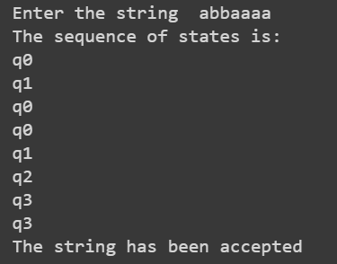

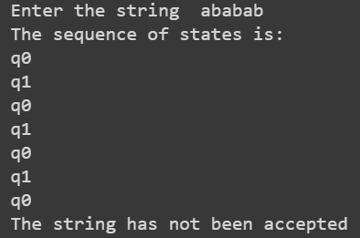

**Conclusion:**

Thus, program for DFA that accepts all strings ending with 3 a's over {a,b} can be written as above**.**